
The purpose of this document is to provide Employee Transportation Coordinators with email templates / blurbs to share November to April Get There Rewards opportunities with employees.

Get There Monthly Rewards (November to April) Description:
Commute by non-drive-alone modes at least TWO times per week to get entered in a raffle where 25 people will win a $25 gift card.
Log at least 16 climate-friendly trips (8 round trips) in GetThereSWWashington.org and automatically get entered in a drawing for gift cards up to a $25 value.
Eligible Modes:
- Transit - Bus, Train
- Bike, E-bike, Electric or Kick Scooter
- Walk
- Skate
- Carpool
- Vanpool
- Remote Work
Log trips by:
- On the 5th of each month for the prior month’s raffle (i.e., log trips by December 5 for the November raffle)

Call to Action for employees:
From November 2025 through April 2026, log 16 non-drive-alone trips each month (or 2 round trips per week!) in GetThereSWWashington.org to automatically get entered in a drawing where 25 people win a $25 e-gift card.

Email Template
Subject: Log trips to earn Get There Rewards!
Hello everyone!
Have you signed up for GetThereSWWashington.org? If not, sign up and log non-drive-alone trips to WIN!
From November 2025 through April 2026, log 16 non-drive-alone trips each month (or 2 round trips per week!) in GetThereSWWashington.org to automatically get entered in a drawing where 25 people win a $25 e-gift card.
Eligible non-drive-alone modes are bus, train, bike, e-bike, electric or kick scooter, walk, skate, carpool, vanpool AND remote work. Yep, that’s right, even if you work from home, you are eligible to win!
Log your trips by the 5th of each month for the prior month’s raffle (i.e., log trips by December 5 for the November raffle).
This promotion runs from November 2025 through April 2026, so keep logging to keep winning!
Learn more online and if you have questions, contact getthereswwa@cityofvancouver.us.
Happy travels,
[ETC Name]

Short Blurb
Get There Rewards Monthly Raffle is from November to April!
From November 2025 through April 2026, log 16 non-drive-alone trips each month (or 2 round trips per week!) in GetThereSWWashington.org to automatically get entered in a drawing where 25 people win a $25 e-gift card.
Learn more online.

Promotional Graphics
Right click and “save as picture” to download these graphics to promote Get There Rewards Monthly Raffle to employees. These graphics are great for your intranet, adding to employee emails, or printing to post in break rooms / common areas.
Banner
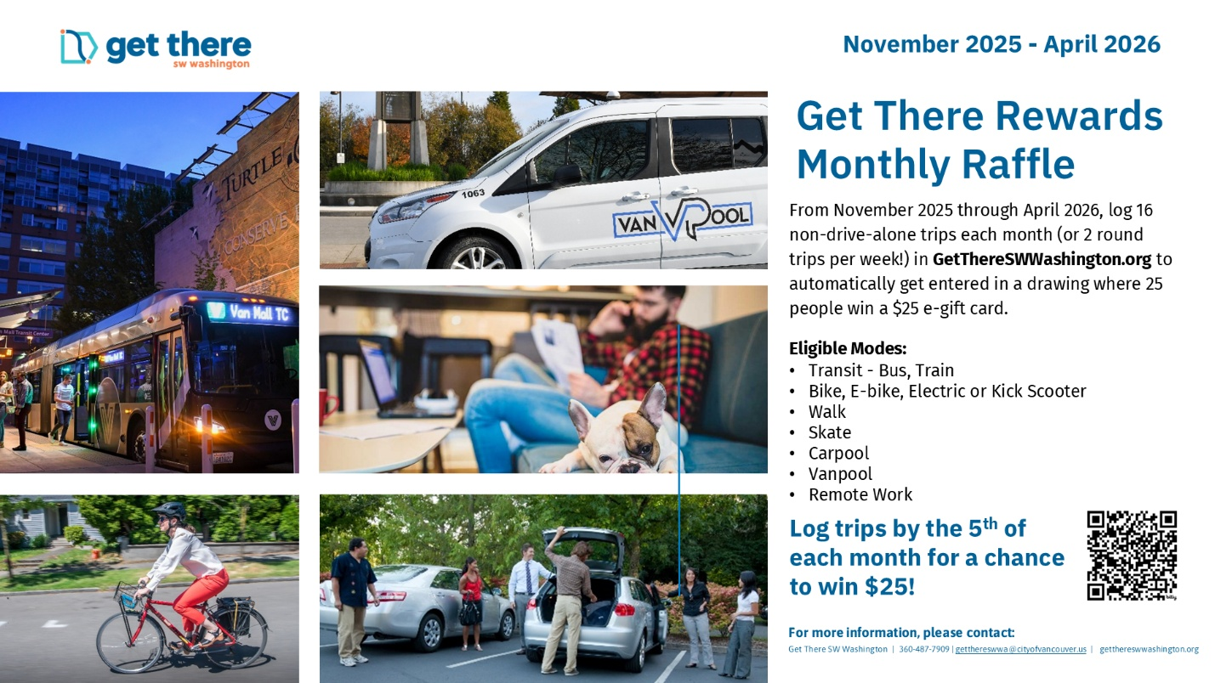

Square Detailed
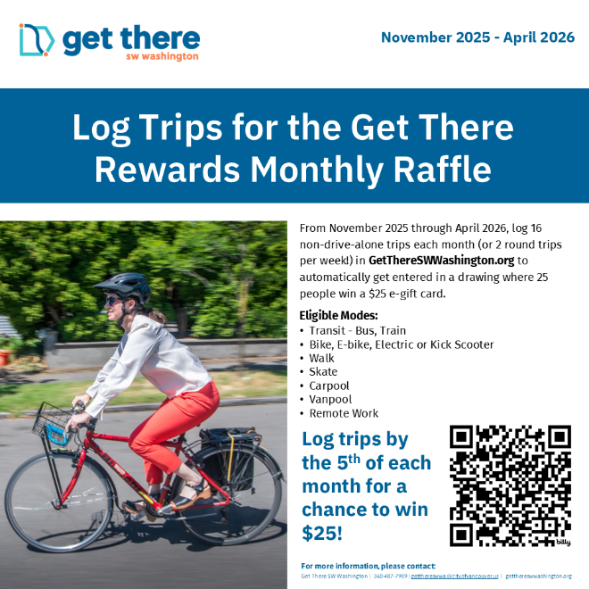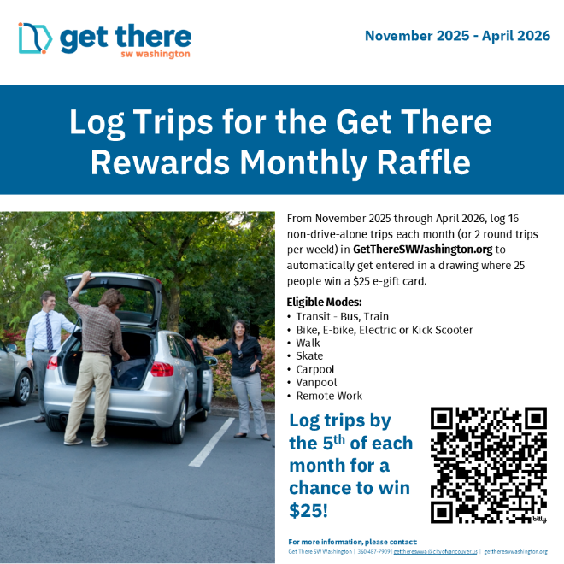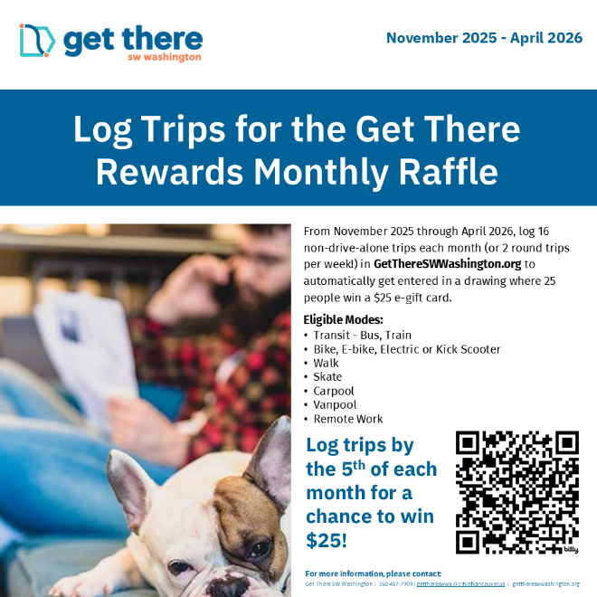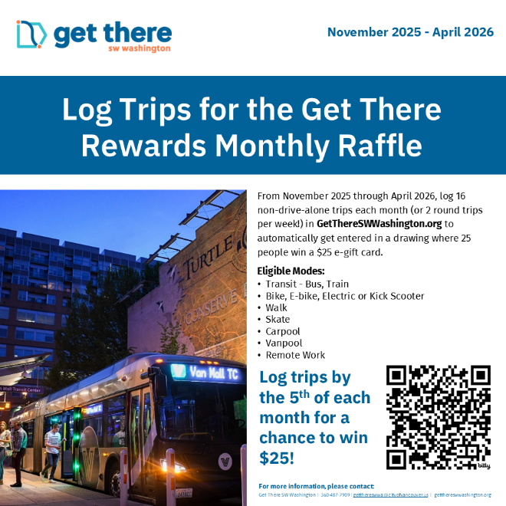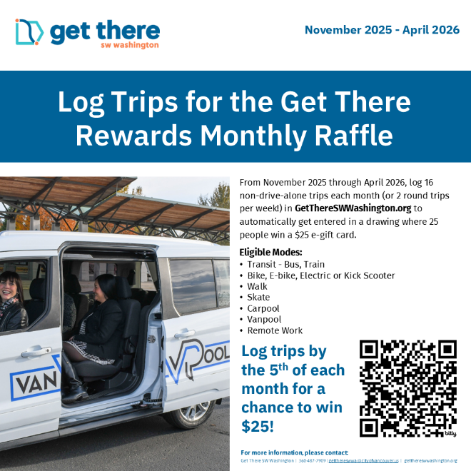

Square Brief
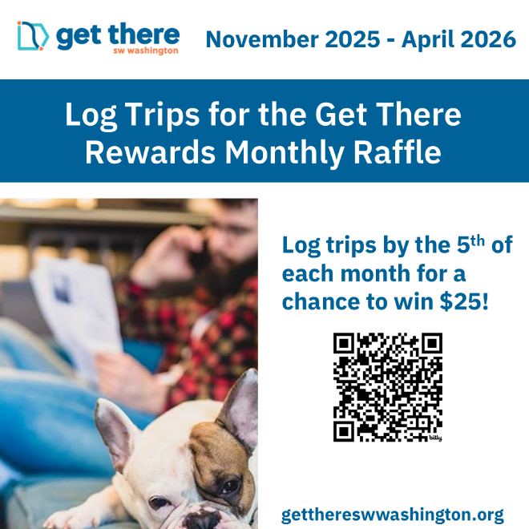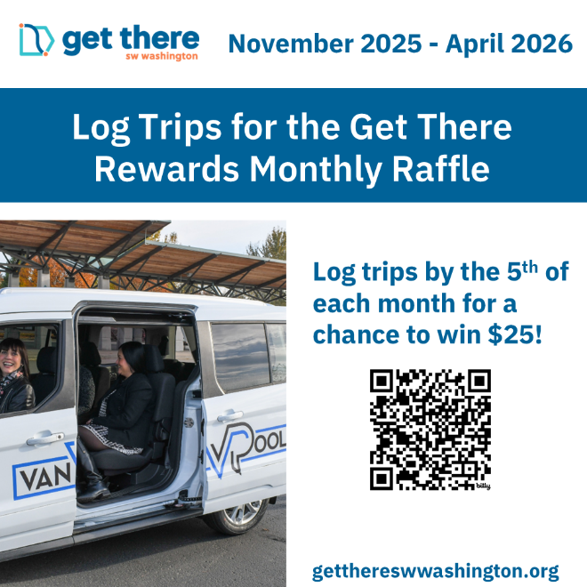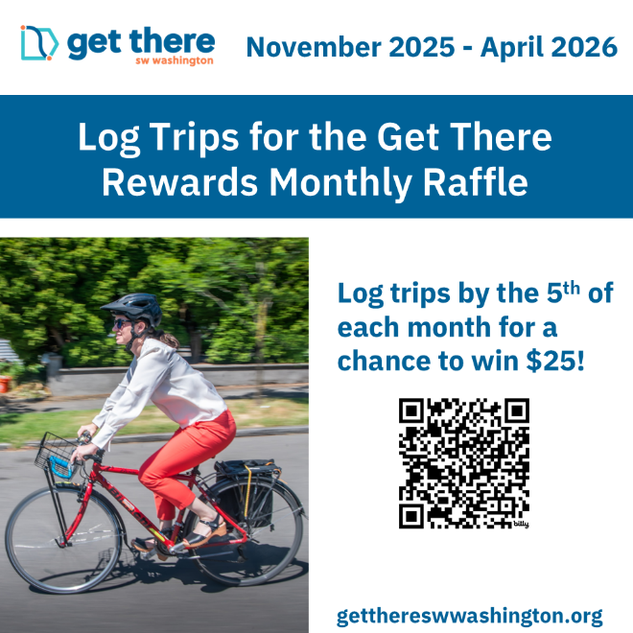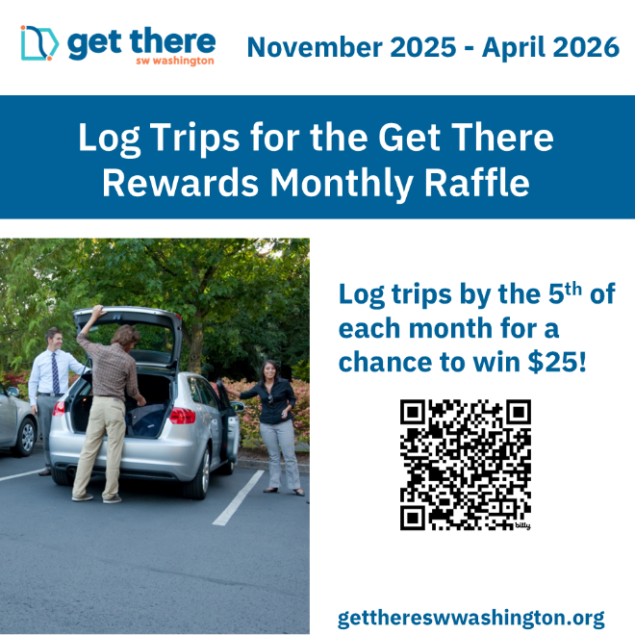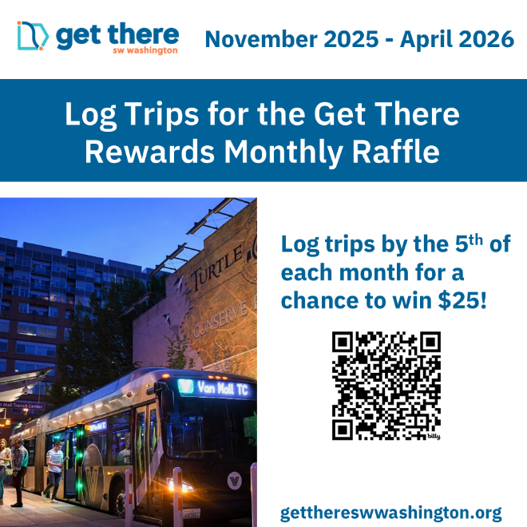

Poster (8.5x11)
